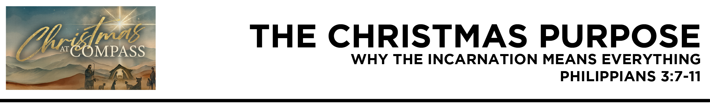

Dr. Mike Fabarez • Compass Bible Church • December 20 & 21, 2025 • Msg. 25-41

Philippians 3:7 But whatever gain I had,
I counted as loss for the sake of Christ. 8 Indeed,
I count everything as loss because of the surpassing worth of knowing Christ Jesus my Lord. For his sake I have suffered the loss of all things and count them as rubbish, in order that I may gain Christ 9 and be found in him, not having a righteousness of my own that comes from the law, but that which comes through faith in Christ, the righteousness from God that depends on faith— 10 that I may know him and the power of his resurrection, and may share his sufferings, becoming like him in his death, 11 that by any means possible I may attain the resurrection from the dead.
(ESV)

- See ________________________________________
(vv.9-10)

- Put ______________________________________
(vv.7-9)

- Live _________________________________________ (vv.10-11)

Application Questions
These questions are provided for your further study and application of today’s sermon. Thoughtfully writing out the answers to these questions will help to drive home the point of today’s study. It is also helpful when you are able to discuss your answers with others. For more information about small groups at Compass Bible Church that utilize these questions as the basis for their weekly discussion, please call the church office at (949) 540-0699 or email us at SmallGroups@CompassChurch.org.

1. Read Titus 3:4-7. This passage is not usually associated with Christmas, but how does it perfectly explain why the incarnation was necessary for our salvation, especially in light of our inability to save ourselves?

2. Read Romans 3:20-24. Can you identify ways you once trusted your own efforts, morality, or obedience—and how this passage confronts that kind of confidence?

3. Read Philippians 2:8-11. Why is it so important for Christians not to forget the cross when they consider the manger?

4. Read 1 Corinthians 1:30-31. What does it mean that Christ is our wisdom, righteousness, sanctification, and redemption, and how does that truth recalibrate our view of ourselves?

5. Read Colossians 1:24-27. How can you, especially during this Christmas season, follow Christ’s pattern of sacrifice in order to extend the hope of Christ to others?

Streaming of both the audio and video of today’s sermon is available on the Compass website (CompassChurch.org). The following related sermons are also available for downloading or streaming on the Focal Point Website and App (FPR.org).
Msg. 22-20 – Grace & Works
Msg. 06-52 – Good Works & Eternal Life: Avoiding the Big Misunderstanding
Msg. 20-37 – The Fruit-Producing Relationship
Msg. 09-19 – Making Sense of Abraham’s Faith & Works
Msg. 07-24 – Looking Past the Pain to the Prize
Msg. 07-12 – Taking Hold of the Hope of a New Start
Msg. 09-10 – Highly Committed Participants: Serving God with Excellence
Here are some books that may assist you in a deeper study of the truths presented in today’s sermon. While Pastor Mike cannot endorse every concept presented in each book, he does believe these resources will be helpful in profitably thinking through today’s topic.
Fabarez, Mike. Share the Umbrella. www.ShareTheUmbrella.com. Accessed September 26, 2025.
House, Paul. Who Will Be Saved? Defending the Biblical Understanding of God & Salvation. Crossway, 2000.
Jeffery, Steve, et al. Pierced for Our Transgressions: Rediscovering the Glory of Penal Substitution. Crossway, 2007.
Kistler, Don. Trust and Obey: Obedience and the Christian. Soli Deo Gloria Ministries, 1997.
Lloyd-Jones, Martyn. Assurance of Our Salvation: Studies in John 17. Crossway Books, 2000.
MacArthur, John. Faith Works: The Gospel According to the Apostles. Zondervan, 1994.
Metzger, Will. Tell the Truth: The Whole Gospel to the Whole Person by Whole People. IVP, 1981.
Morris, Leon. The Atonement: Its Meaning and Significance. InterVarsity, 1984.
________. The Lord from Heaven: A Study of New Testament Teaching on the Deity & Humanity of Christ. IVP, 1974.
Pritchard, Ray. An Anchor for the Soul: Help for the Present, Hope for the Future. Moody Press, 2000.
Sproul, R. C. Faith Alone: The Evangelical Doctrine of Justification. Baker Books, 1995.
Ware, Bruce. The Man Christ Jesus: Theological Reflections on the Humanity of Christ. Crossway, 2013.
Whitney, Donald. How Can I Be Sure I’m a Christian? What the Bible Says About Assurance. NavPress, 1994.
Daily Bible Reading Schedule
Dec. 21st Mic.6-7 & Rev.12
Dec. 22nd Nah.1-3 & Rev.13
Dec. 23rd Hab.1-3 & Rev.14
Dec. 24th Zeph.1-3 & Rev.15
Dec. 25th Hag.1-2 & Rev.16
Dec. 26th Zech.1-3 & Rev.17
Dec. 27th Zech.4-6 & Rev.18
Dec. 28th Zech.7-9 & Rev.

