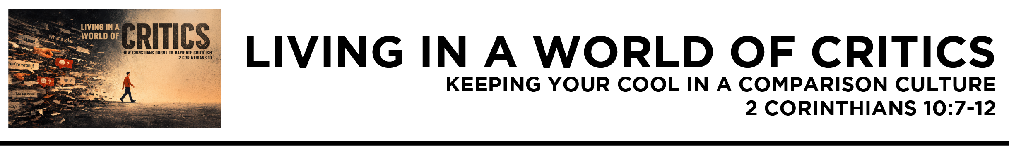

2 Cor. 10:7 Look at what is before your eyes. If anyone is confident that he is Christ's, let him remind himself that just as he is Christ's, so also are we. 8 For even if I boast a little too much of our authority, which the Lord gave for building you up and not for destroying you, I will not be ashamed. 9 I do not want to appear to be frightening you with my letters. 10 For they say, “His letters are weighty and strong, but his bodily presence is weak, and his speech of no account.” 11 Let such a person understand that what we say by letter when absent, we do when present. 12 Not that
we dare to classify or compare ourselves
with some of those who are commending themselves. But when they measure themselves by one another and compare themselves with one another, they are without understanding.
(ESV)
Dr. Mike Fabarez • Compass Bible Church • March 28 & 29, 2026 • 2 Corinthians, week 43 • Msg. 26-11

- Expect _______________________________ (v.7)

- Expect ______________________________________
(vv.8-11)

- Refuse ______________________________________ (v.12)

Application Questions
These questions are provided for your further study and application of today’s sermon. Thoughtfully writing out the answers to these questions will help to drive home the point of today’s study. It is also helpful when you are able to discuss your answers with others. For more information about small groups at Compass Bible Church that utilize these questions as the basis for their weekly discussion, please call the church office at (949) 540-0699 or email us at SmallGroups@CompassChurch.org.

1. Read 1 Samuel 16:7. Where are you most tempted to evaluate people based on appearance, style, or status instead of spiritual character and standing in Christ?

2. Read 1 Corinthians 4:12-13. How would you encourage a young Christian to stay faithful when their efforts to do what is right are misunderstood or criticized?

3. Read Luke 18:11-12. What do you think drives the temptation to measure ourselves against others, and how does that distort our thinking? What steps can you take to eliminate this pattern of thinking?

4. Read 1 Corinthians 1:25-31. How does remembering that God often chooses the “weak” and “lowly,” like David the shepherd, help protect us from pride and comparison?

5. Read Isaiah 53:2-3. How should these prophecies shape the way we understand people’s responses to Christ at his first coming and to the gospel today?

Streaming of both the audio and video of today’s sermon is available on the Compass website (CompassChurch.org). The following related sermons are also available for downloading or streaming on the Focal Point Website and App (FPR.org).
Msg. 24-17 – The Power of Integrity
Msg. 22-12 – Aiming for “Well Done”
Msg. 14-05 – The Practical Value of Integrity
Msg. 15-32 – The Fear of Being Fake
Msg. 11-35 – Keeping a Clear Conscience
Msg. 08-16 – Why It’s All Worth It
Msg. 25-24 – Investing in Our Post-Resurrection Life
Here are some books that may assist you in a deeper study of the truths presented in today’s sermon. While Pastor Mike cannot endorse every concept presented in each book, he does believe these resources will be helpful in profitably thinking through today’s topic.
Dillehay, Tilly. Seeing Green: Don’t Let Envy Color Your Joy. Harvest House, 2018.
Elliott, Elisabeth. The Path of Loneliness: Finding Your Way through the Wilderness to God. Revell, 1988.
Fabarez, Mike. Envy: A Big Problem You Didn’t Know You Had. Moody Publishers, 2023.
Frank, Arnold L. The Fear of God: A Forgotten Doctrine. Nordskog Publishing, 2008.
Hitchcock, Mark. Heavenly Rewards: Living with Eternity in Sight. Harvest House, 2019.
Mack, Wayne A. Humility: The Forgotten Virtue. P & R Publishing, 2005.
MacArthur, John. The Power of Integrity: Building a Life Without Compromise. Crossway, 1997.
Morgan, Christopher W. Suffering and the Goodness of God. Crossway, 2008.
Piper, John. A Godward Life: Savoring the Supremacy of God in All of Life. Multnomah Press, 2009.
Piper, John, and Justin Taylor, eds. Suffering and the Sovereignty of God. Crossway, 2006.
Smith, William P. How to Love Difficult People: Receiving and Sharing God’s Mercy. New Growth Press, 2008.
Swindoll, Charles R. Joseph: A Man of Integrity and Forgiveness. Thomas Nelson, 1998.
Wiersbe, Warren. The Integrity Crisis. Oliver-Nelson Books, 1988.
Daily Bible Reading Schedule
March 29th Josh.23-24 & Lk.6:27-49
March 30th Judg.1-2 & Lk.7:1-30
March 31st Judg.3-5 & Lk.7:31-50
April 1st Judg.6-7 & Lk.8:1-21
April 2nd Judg.8-9 & Lk.8:22-56
April 3rd Judg.10-11 & Lk.9:1-36
April 4th Judg.12-14 & Lk.9:37-62
April 5th Judg.15-17 & Lk.10:1-24

