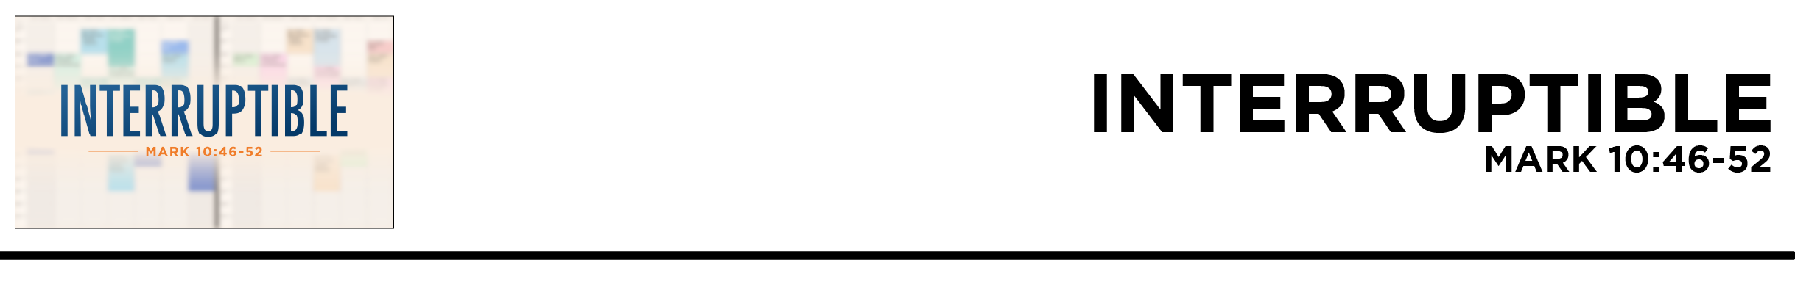

Mark 10:46-52 And they came to Jericho. And as
he was leaving Jericho
with his disciples and a great crowd, Bartimaeus,
a blind beggar, the son of
Timaeus, was sitting by
the roadside. 47 And when he heard that it was Jesus of Nazareth, he began to cry out and say, “Jesus, Son of David, have mercy on me!” 48 And many rebuked him, telling him
to be silent. But he cried out all the more, “Son of David, have mercy on me!” 49 And Jesus stopped and said, “Call him.” And they called the blind man, saying to him, “Take heart. Get up; he is calling you.” 50 And throwing off his cloak, he sprang up and came to Jesus. 51 And Jesus said to him, “What do you want me to do for you?” And the blind man said to him, “Rabbi, let
me recover my sight.”
52 And Jesus said to him, “Go your way; your faith has made you well.” And immediately he recovered his sight and followed him on the way. (ESV)
Kellen Allen • Compass Bible Church • May 16 & 17, 2026 • Msg. G26-03

- Prioritize __________________________________
(vv.46, 48a)

- Pay ___________________________________ (v.49)

- Expect _____________________________________ (vv.47, 48b, 50-52)

Application Questions
These questions are provided for your further study and application of today’s sermon. Thoughtfully writing out the answers to these questions will help to drive home the point of today’s study. It is also helpful when you are able to discuss your answers with others. For more information about small groups at Compass Bible Church that utilize these questions as the basis for their weekly discussion, please call the church office at (949) 540-0699 or email us at SmallGroups@CompassChurch.org.

1. Read Acts 16:6-10. Share a time God interrupted your plans for something more fruitful for His glory. How did you initially respond?

2. Read Jonah 1:1-3. How have you ignored or resisted God’s interruptions in your life? How can you become more attentive to them?

3. Read Proverbs 16:3, 9; and 21:5. What ungodly outcomes come from gripping too tightly to your plans—or from not planning at all? What does it look like to plan wisely while remaining open to God’s interruptions?

4. Read Romans 12:1-2. Where might God be using interruptions in your life to grow you spiritually?

5. Read Mark 10:47-52. How does Bartimaeus’ eagerness and faith in Jesus motivate your pursuit of Christ? What keeps you from pursuing him eagerly at all times?

This Week’s
Bible Reading Schedule
May 17th
2Kgs.18-19 & Jn.6:22-44
May 18th
2Kgs.20-22 & Jn.6:45-71
May 19th
2Kgs.23-25 & Jn.7:1-31
May 20th
1Chr.1-2 & Jn.7:32-53
May 21st
1Chr.3-5 & Jn.8:1-20
May 22nd
1Chr.6-7 & Jn.8:21-36
May 23rd
1Chr.8-10 & Jn.8:37-59
May 24th
1Chr.11-13 & Jn.9:1-23

