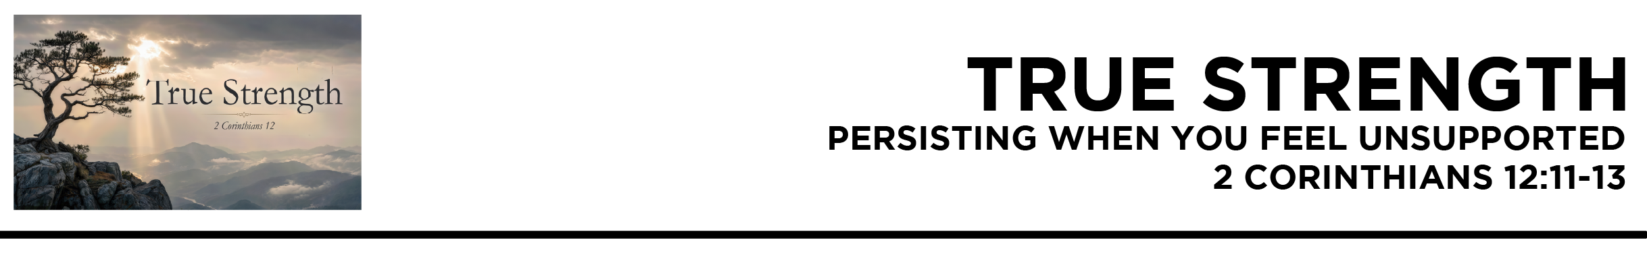

2 Cor. 12:11 I have been a fool! You forced me to it, for I ought to have been commended by you. For I was not
at all inferior to these
super-apostles, even though I am nothing.
12 The signs of a true apostle were performed among you with utmost patience, with signs and wonders and mighty works. 13 For in what were you less favored than the rest of the churches, except that
I myself did not burden you? Forgive me this wrong! (ESV)
Dr. Mike Fabarez • Compass Bible Church • June 20 & 21, 2026 • 2 Corinthians, week 52 • Msg. 26-22

- Don’t _______________________________________
(v.11a)

- Keep _________________________________________ (vv.11b-12)

- Realize ________________________________________ (v.13)

Application Questions
These questions are provided for your further study and application of today’s sermon. Thoughtfully writing out the answers to these questions will help to drive home the point of today’s study. It is also helpful when you are able to discuss your answers with others. For more information about small groups at Compass Bible Church that utilize these questions as the basis for their weekly discussion, please call the church office at (949) 540-0699 or email us at SmallGroups@CompassChurch.org.

1. Read John 12:42-43 and Galatians 1:10. One of the constant battles of Christian living is keeping straight whose approval we're living for. Why is this so hard, and how do you keep Christ's approval central in your heart and mind?

2. Read Jeremiah 17:5. What happens when your joy, confidence, or motivation rises and falls based on the opinions of others? How does this passage expose the danger of that kind of dependence?

3. Read 2 Corinthians 6:4. Endurance is often most difficult when our efforts seem unnoticed, unappreciated, or unsupported. Where do you most need God’s help to keep doing what is right, even when encouragement is scarce?

4. Read Acts 7:55-60. When Stephen was being rejected by people, he was seeing Christ’s welcome. How does this encourage you to focus more on Christ’s evaluation than on the opinions of the critics around you?

5. Read Matthew 6:1-4. How can the desire to be noticed, appreciated, or praised subtly influence our service for God? How does Jesus’ instruction here help you find satisfaction in God’s approval rather than the applause of others?

Streaming of both the audio and video of today’s sermon is available on the Compass website (CompassChurch.org). The following related sermons are also available for downloading or streaming on the Focal Point Website and App (FPR.org).
Msg. 22-12 – Aiming for “Well Done”
Msg. 07-05 – Motivated by Christ’s Rewards at His Return
Msg. 24-08 – The Callings & Purposes of God
Msg. 17-34 – Living the Christian Life
Msg. 16-04 – The Fear of Responsibility
Msg. 16-27 – Worldly Profits & Godly Investments
Msg. 13-23 – Urgency & True Importance
Here are some books that may assist you in a deeper study of the truths presented in today’s sermon. While Pastor Mike cannot endorse every concept presented in each book, he does believe these resources will be helpful in profitably thinking through today’s topic.
Alcorn, Randy. Money, Possessions, and Eternity. Tyndale House, 2003.
Archer, Clint. The Preacher’s Payday: How Faithfulness Echoes in Eternity. Day One Publications, 2012.
Epp, Theodore H. Present Labor and Future Rewards: The Believer, His Sin, Conduct & Rewards. BTTB, 1960.
Fabarez, Mike. Lifelines for Tough Times: God’s Presence and Help When You Hurt. Harvest House Publishers, 2014.
Guinness, Os. The Call: Finding and Fulfilling the Central Purpose of Your Life. Word Publishing, 1998.
MacArthur, John. Slave: The Hidden Truth About Your Identity in Christ. Thomas Nelson, 2010.
Pink, A. W. Our Accountability to God. Moody Publishers, 1999.
Piper, John. Brothers, We Are Not Professionals: A Plea to Pastors for Radical Ministry. B&H Publishing Group, 2013.
Ryken, Leland. Redeeming the Time: A Christian Approach to Work and Leisure. Baker Books, 1995.
Sweeting, Donald. How to Finish the Christian Life: Following Jesus in the Second Half. Moody Press, 2012.
Tozer, A. W. The Root of Righteousness. Christian Publications, 1955.
Welch, Edward T. When People Are Big and God Is Small. P&R Publishing, 1997.
Wilkinson, Bruce. A Life God Rewards: Why Everything You Do Today Matters Forever. Multnomah Books, 2002.
Daily Bible Reading Schedule
June 21st Esth.1-3 & Ac.5:1-16
June 22nd Esth.4-6 & Ac.5:17-42
June 23rd Esth.7-8 & Ac.6
June 24th Job 1-3 & Ac.7:1-19
June 25th Job 4-6 & Ac.7:20-43
June 26th Job 7-9 & Ac.7:44-60
June 27th Job 10-12 & Ac.8:1-25
June 28th Job 13-15 & Ac.8:26-40

