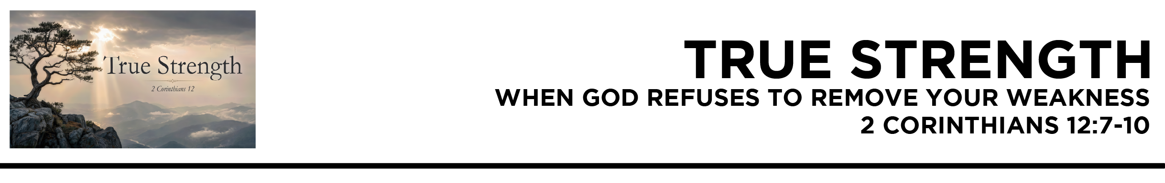

2 Cor. 12:7 So to keep me from becoming conceited because of the surpassing greatness of the revelations, a thorn was given me in the flesh, a messenger of Satan to harass me, to keep me from becoming conceited. 8 Three times I pleaded with the Lord about this, that it should leave me. 9 But he said to me, “My grace is sufficient for you, for my power is made perfect in weakness.” Therefore
I will boast all the more gladly of my weaknesses, so that the power of Christ may rest upon me.
10 For the sake of Christ, then, I am content with weaknesses, insults, hardships, persecutions, and calamities. For
when I am weak, then
I am strong. (ESV)
Dr. Mike Fabarez • Compass Bible Church • June 6 & 7, 2026 • 2 Corinthians, week 51 • Msg. 26-21

- When ___________________________________ (v.8)

- Seek __________________________________ (v.7)

- Accept __________________________________________ (vv.9-10)

Application Questions
These questions are provided for your further study and application of today’s sermon. Thoughtfully writing out the answers to these questions will help to drive home the point of today’s study. It is also helpful when you are able to discuss your answers with others. For more information about small groups at Compass Bible Church that utilize these questions as the basis for their weekly discussion, please call the church office at (949) 540-0699 or email us at SmallGroups@CompassChurch.org.

1. Read Philippians 4:6. Nobody needs to be told to pray when they're sick. But what does it do to your thoughts about God when the illness drags on and God doesn’t give you the recovery you have kept asking for?

2. Read Matthew 26:39. If anyone deserved a yes answer to his prayers it was Jesus. But he didn't get one. What should that tell us about our own unanswered prayers for relief?

3. Read James 1:2-5. We would like to think we could be maximally useful for Christ without any trials — but we can’t. Why do you suppose the text immediately points us to prayer for wisdom when we are in the middle of them?

4. Read Isaiah 66:1-2. God specifies exactly the kind of person he looks to. How might that make your persistent weakness an asset rather than a liability?

5. Read Daniel 2:30. Daniel reduces his own role to this: God had a job, and he was chosen to do it. How can that mindset keep you humble when God uses you to make a significant impact?

Streaming of both the audio and video of today’s sermon is available on the Compass website (CompassChurch.org). The following related sermons are also available for downloading or streaming on the Focal Point Website and App (FPR.org).
Msg. 14-08 – Anticipating the Defeat of Disease
Msg. 20-01 – Proclaiming Christ’s Power
Msg. 13-29 – Confident in His Power to Restore
Msg. 16-15 – Suffering in a Broken World
Msg. 10-19 – Looking for the Good When Things Go Bad
Msg. 06-28 – Impeccable Promises & Divine Character
Msg. 07-10 – Reaching Forward with the Hope of a New World
Here are some books that may assist you in a deeper study of the truths presented in today’s sermon. While Pastor Mike cannot endorse every concept presented in each book, he does believe these resources will be helpful in profitably thinking through today’s topic.
Alcorn, Randy. If God Is Good: Faith in the Midst of Suffering and Evil. Multnomah Books, 2014.
Bonar, Horatius. Night of Weeping: When God’s Children Suffer. Christian Focus Publications, 1999.
Bowman, Robert M. The Word-Faith Controversy: Understanding the Health and Wealth Gospel. Baker Books, 2001.
Burroughs, Jeremiah. The Rare Jewel of Christian Contentment. Banner of Truth, 1981.
Carson, D. A. How Long, O Lord? Reflections on Suffering and Evil. Baker Books, 1990.
Henry, Matthew. The Pleasantness of a Religious Life. Christian Focus Publications, 1998.
Lewis, C. S. The Problem of Pain. B&H Publishing Group, 2000.
Leyshon, David. Sickness, Suffering and Scripture. Banner of Truth, 2008.
Lutzer, Erwin W. The Vanishing Power of Death. Moody Publishers, 2004.
Mayhue, Richard. The Healing Promise: Is It Always God’s Will to Heal? Mentor Books, 1997.
Morgan, Christopher W. Suffering and the Goodness of God. Crossway, 2008.
Watson, Thomas. All Things for Good. Banner of Truth, 1986.
Wiersbe, Warren W., ed. Classic Sermons on Suffering. Kregel Publications, 1984.

Daily Bible Reading Schedule
June 7th 2Chr.23-25 & Jn.16:16-33
June 8th 2Chr.26-28 & Jn.17
June 9th 2Chr.29-31 & Jn.18:1-23
June 10th 2Chr.32-33 & Jn.18:24-40
June 11th 2Chr.34-36 & Jn.19:1-22
June 12th Ezra 1-2 & Jn.19:23-42
June 13th Ezra 3-5 & Jn.20
June 14th Ezra 6-8 & Jn.21

