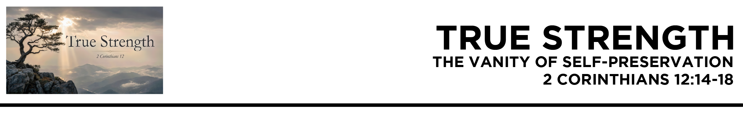

2 Cor. 12:14 Here for
the third time I am ready to come to you. And I will not be a burden, for I seek not what is yours but you. For children are not obligated to save up
for their parents, but parents for their children. 15 I will most gladly spend and be spent for your souls.
If I love you more, am
I to be loved less?
16 But granting that
I myself did not burden you, I was crafty, you say, and got the better of you by deceit. 17 Did I take advantage of you through any of those whom I sent to you? 18 I urged Titus to go, and sent the brother with him. Did Titus take advantage
of you? Did we not act in the same spirit? Did we not take the same steps? (ESV)
Dr. Mike Fabarez • Compass Bible Church • June 27 & 28, 2026 • 2 Corinthians, week 53 • Msg. 26-23

- Reject _____________________________________
(v.14a)

- Embrace ______________________________ (vv.14b-15)

- Team ________________________________ (vv.16-18)

Application Questions
These questions are provided for your further study and application of today’s sermon. Thoughtfully writing out the answers to these questions will help to drive home the point of today’s study. It is also helpful when you are able to discuss your answers with others. For more information about small groups at Compass Bible Church that utilize these questions as the basis for their weekly discussion, please call the church office at (949) 540-0699 or email us at SmallGroups@CompassChurch.org.

1. Read Luke 9:23-24. Self-preservation feels instinctively reasonable, even wise. What does it look like in daily life when a Christian genuinely rejects that temptation and chooses self-sacrifice instead?

2. Read Philippians 2:3-4. God defines love as counting others more significant than yourself. How does our culture redefine love in ways that are essentially the polar opposite of what is described here?

3. Read Colossians 1:24-26. Paul rejoiced in suffering for the sake of making Christ fully known. What specific person or opportunity have you been avoiding because the cost felt too high?

4. Read Proverbs 13:20. Your closest companions are either pushing you toward sacrificial ministry or steering you toward self-preservation. Which direction is your inner circle currently moving you and what needs to change?

5. Read Romans 16:3-4. Prisca and Aquila risked their lives for Paul and the ministry. Who in your life is serving others at real personal cost, and what specific gratitude do they deserve to hear from you?

Streaming of both the audio and video of today’s sermon is available on the Compass website (CompassChurch.org). The following related sermons are also available for downloading or streaming on the Focal Point Website and App (FPR.org).
Msg. 21-27 – Prepared by a Godly Example
Msg. 07-33 – Sacrifice Instead of Selfishness
Msg. 14-02 – Exceptional Love with Exceptional Motives
Msg. 11-07 – Excelling in Generosity
Msg. 14-40 – Reflecting the Incarnational Love of Christ
Msg. 09-10 – Highly Committed Participants: Serving God with Excellence
Msg. 19-31 – Coached by the Right Leaders
Here are some books that may assist you in a deeper study of the truths presented in today’s sermon. While Pastor Mike cannot endorse every concept presented in each book, he does believe these resources will be helpful in profitably thinking through today’s topic.
Berding, Kenneth. What Are Spiritual Gifts? Rethinking the Conventional View. Kregel Publications, 2006.
Coleman, Robert E. The Master Plan of Evangelism. Spire Books, 1963.
Engstrom, Ted W. The Making of a Christian Leader. Zondervan, 1976.
Guinness, Os. The Call: Finding and Fulfilling the Central Purpose of Your Life. Word Publishing, 1998.
Laniak, Timothy S. Shepherds After My Own Heart: Pastoral Traditions and Leadership in the Bible. IVP, 2006.
Sanders, J. Oswald. Spiritual Leadership: Principles of Excellence for Every Believer. Moody Press, 1994.
Sauls, Scott. From Weakness to Strength. David C Cook, 2017.
Spurgeon, Charles H. Lectures to My Students. Hendrickson Publications, 2010.
Stott, John R. W. Basic Christian Leadership. InterVarsity Press, 2006.
Swindoll, Charles R. Improving Your Serve: The Art of Unselfish Living. Word, 2002.
Whitney, Donald S. Spiritual Disciplines Within the Church. Moody Press, 1996.
Wiersbe, Warren W. Living with the Giants: The Lives of Great Men of the Faith. Baker Books, 1993.
Woodbridge, John D., ed. Great Leaders of the Christian Church. Moody Press, 1988.

Daily Bible Reading Schedule
June 28th Job 13-15 & Ac.8:26-40
June 29th Job 16-18 & Ac.9:1-22
June 30th Job 19-20 & Ac.9:23-43
July 1st Job 21-22 & Ac.10:1-23
July 2nd Job 23-25 & Ac.10-24-48
July 3rd Job 26-28 & Ac.11
July 4th Job 29-30 & Ac.12
July 5th Job 31-32 & Ac.13:1-23

