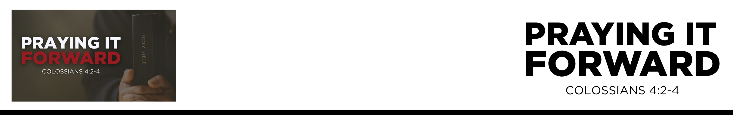

Colossians 4:2
Continue steadfastly in prayer, being watchful in it with thanksgiving. 3 At the same time, pray also for us, that God may open to us a door for the word, to declare the mystery of Christ, on account of which I am in prison—
4 that I may make it clear, which is how
I ought to speak. (ESV)
John Fabarez • Compass Bible Church • June 13 & 14, 2026 • Msg. G26-04

- _______________________________________ (v.2)

- _______________________________________ (vv.3-4)

Application Questions
These questions are provided for your further study and application of today’s sermon. Thoughtfully writing out the answers to these questions will help to drive home the point of today’s study. It is also helpful when you are able to discuss your answers with others. For more information about small groups at Compass Bible Church that utilize these questions as the basis for their weekly discussion, please call the church office at (949) 540-0699 or email us at SmallGroups@CompassChurch.org.

1. Read Romans 12:12. Constant prayer sounds straightforward until we examine our own lives. What do you think explains the gap between what we know we should do and what we actually do?

2. Read Daniel 6:10. Daniel obviously had some established patterns and habits for his prayer life. What specific patterns could you build into your daily life to make your praying more consistent and sustainable?

3. Read 1 Peter 4:7. Beyond simply finding a time and a place to pray, what practically helps you show up
mentally — fully present and genuinely engaged, rather than just going through the motions?

4. Read 1 Timothy 2:1-3. Most of us spend the bulk of our prayer time on ourselves and our immediate circle. What are the most common excuses Christians make for not praying more broadly for others?

5. Read Colossians 4:3-6. Paul prays for open doors, clear proclamation, and wise, gracious witness toward outsiders. Why should we all be motivated to pray for gospel advancement, clarity, and skill in sharing Christ?

This Week’s
Bible Reading Schedule
June 14th
Ezra 6-8 & Jn.21
June 15th
Ezra 9-10 & Ac.1
June 16th
Neh.1-3 & Ac.2:1-13
June 17th
Neh.4-6 & Ac.2:14-47
June 18th
Neh.7-8 & Ac.3
June 19th
Neh.9-11 & Ac.4:1-22
June 20th
Neh.12-13 & Ac.4:23-37
June 21st
Esth.1-3 & Ac.5:1-16

