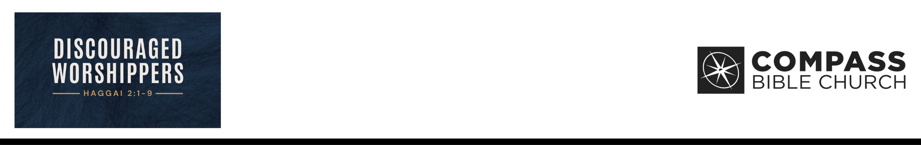

When Relating to God by Faith …
Haggai 2:1 In the seventh month, on the twenty-first day
of the month, the word of the LORD came by the hand of Haggai the prophet: 2 “Speak now to Zerubbabel the son of Shealtiel, governor of Judah, and to Joshua the son of Jehozadak, the high priest, and to all the remnant of the people, and say, 3 ‘Who is left among you who saw this house in its former glory? How do you see
it now? Is it not as nothing in your eyes? 4 Yet now be strong, O Zerubbabel, declares the LORD. Be strong, O Joshua, son of Jehozadak, the high priest. Be strong, all you people of the land, declares the LORD. Work, for I am with you, declares the LORD of hosts, 5 according to the covenant that I made with you when you came out of Egypt. My Spirit remains in your midst. Fear not. 6 For thus says the LORD of hosts: Yet once more, in a little while, I will shake the heavens and the earth and the sea and the dry land. 7 And
I will shake all nations, so that the treasures of all nations shall come in, and I will fill this house with glory, says the LORD of hosts. 8 The silver is mine, and the gold is mine, declares the LORD of hosts. 9 The latter glory of this house shall be greater than the former, says the LORD of hosts. And in this place I will give peace, declares the LORD of hosts.’” (ESV)
Adam Bailie • Compass Bible Church • July 25 & 26, 2026 • Msg. G26-05

- Be ______________________________________
(vv.1-3)

- Be _______________________________ (vv.4-9)

- Be _______________________________ (vv.4b-5)

- Be _________________________________ (vv.6-8)

Application Questions
These questions are provided for your further study and application of today’s sermon. Thoughtfully writing out the answers to these questions will help to drive home the point of today’s study. It is also helpful when you are able to discuss your answers with others. For more information about small groups at Compass Bible Church that utilize these questions as the basis for their weekly discussion, please call the church office at (949) 540-0699 or email us at SmallGroups@CompassChurch.org.

1. Do I fundamentally relate to God by faith or by works? Explain.

2. How can I functionally cultivate my faith this week? Explain.

3. What circumstances stand as the greatest threat to my worship? Expound.

4. Who is my model of worship in real life? Encourage.

5. Who can I call to walk in faith as a disciple of Christ? Engage.

This Week’s
Bible Reading Schedule
July 26th
Ps.47-49 & Ac.26
July 27th
Ps.50-52 & Ac.27:1-25
July 28th
Ps.53-55 & Ac.27:26-44
July 29th
Ps.56-58 & Ac.28:1-15
July 30th
Ps.59-61 & Ac.28:16-31
July 31st
Ps.62-64 & Ro.1
August 1st
Ps.65-67 & Ro.2
August 2nd
Ps.68-69 & Ro.3

