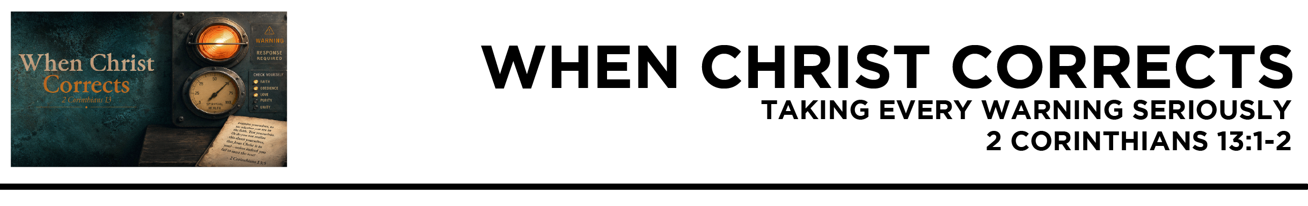

2 Cor. 13:1 This is the third time I am coming to you. Every charge must be established by the evidence of two or three witnesses. 2 I warned those who sinned before and all the others, and
I warn them now while absent, as I did when present on my second visit, that if I come again I will not spare them—
(ESV)
Dr. Mike Fabarez • Compass Bible Church • August 8 & 9, 2026 • 2 Corinthians, week 55 • Msg. 26-27

- Learn __________________________________ (v.1)

- Know ___________________________________________ (v.2a)

- Take ________________________________________ (v.2b)

Application Questions
These questions are provided for your further study and application of today’s sermon. Thoughtfully writing out the answers to these questions will help to drive home the point of today’s study. It is also helpful when you are able to discuss your answers with others. For more information about small groups at Compass Bible Church that utilize these questions as the basis for their weekly discussion, please call the church office at (949) 540-0699 or email us at SmallGroups@CompassChurch.org.

1. Read 1 Peter 1:14-17. Why should God’s commitment to your holiness make you more willing to receive uncomfortable correction?

2. Read Hebrews 12:5-11. Though God's discipline is painful in the moment, why should it be reassuring to us? How specifically have you experienced that reassurance in your own life?

3. Read Acts 5:1-11. Why do you think God chose to deal so severely with this sin at such an early stage in the life of the church? How might witnessing it have changed the way you viewed your own sin?

4. Read 2 Timothy 3:16-17. Understanding that Scripture is our clear and unalterable standard for correction, how can your spiritual disciplines and habits be strengthened to keep you regularly exposed to God’s written Word?

5. Read Proverbs 9:7-9. What can you do now to ensure that your next response to correction (especially when it comes through another person) is better than your last one?

Streaming of both the audio and video of today’s sermon is available on the Compass website (CompassChurch.org). The following related sermons are also available for downloading or streaming on the Focal Point Website and App (FPR.org).
Msg. 17-10 – Caring for the Wandering Sheep of Your Church
Msg. 13-30 – Apostasy & Stumbling Saints
Msg. 11-27 – The Centrality of Scripture & Expository Preaching
Msg. 11-15 – Making the Most of Daily Bible Study
Msg. 16-13 – Knowing Genuine Repentance
Msg. 07-20 – Courage to Do the Right Thing
Msg. 14-18 – 14-24 Ears Up! (a seven-part series on receptivity to God’s word)

Here are some books that may assist you in a deeper study of the truths presented in today’s sermon. While Pastor Mike cannot endorse every concept presented in each book, he does believe these resources will be helpful in profitably thinking through today’s topic.
Adams, Jay E. A Consumer’s Guide to Preaching. Victor Books, 1991.
Burroughs, Jeremiah. Gospel Fear: Developing a Tender Heart that Trembles at the Word of God. Soli Deo Gloria, 1997.
DeYoung, Kevin. The Hole in Our Holiness. Crossway, 2012.
Fabarez, Mike. Sanctification: Thinking Rightly About Our Christian Growth. Compass Press, 2017.
Love, Christopher. The Mortified Christian. Soli Deo Gloria Publications, 1998.
MacArthur, John. The Vanishing Conscience. Word Publishing, 1994.
Ortlund, Raymond C., Jr. God’s Unfaithful Wife: A Biblical Theology of Spiritual Adultery. InterVarsity Press, 2001.
Owen, John. Overcoming Sin & Temptation. Crossway Books, 2006.
Pache, René. The Inspiration and Authority of Scripture. Moody Press, 1969.
Packer, J. I. Rediscovering Holiness. Servant Publications, 1999.
Ramey, Ken. Expository Listening: A Handbook for Hearing and Doing God’s Word. Kress Christian Publications, 2010.
Ryle, J. C. Holiness: Its Nature, Hindrances, Difficulties and Roots. Charles Nolan Publishers, 2001.
Thoennes, K. Erik. Godly Jealousy: A Theology of Intolerant Love. Christian Focus Publications, 2005.
Daily Bible Reading Schedule
Aug. 9th Ps.85-87 & Ro.9
Aug. 10th Ps.88-89 & Ro.10
Aug. 11th Ps.90-92 & Ro.11:1-21
Aug.12th Ps.93-95 & Ro.11:22-36
Aug. 13th Ps.96-98 & Ro.12
Aug. 14th Ps.99-102 & Ro.13
Aug. 15th Ps.103-104 & Ro.14
Aug. 16th Ps.105-106 & Ro.15:1-20

