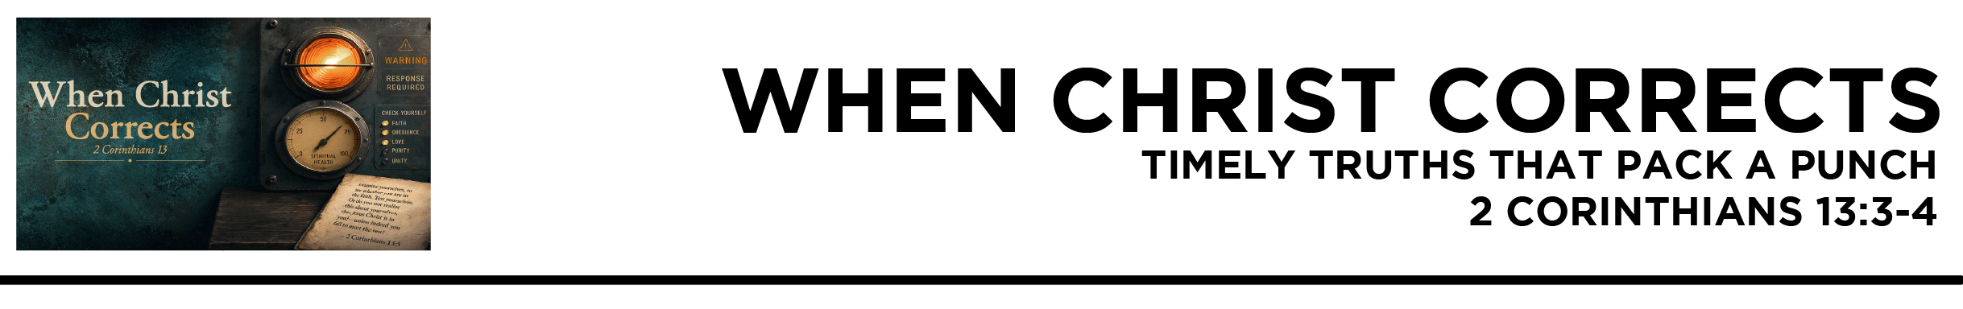

2 Cor. 13:3 since you seek proof that Christ is speaking in me.
He is not weak in dealing with you, but
is powerful among you.
4 For he was crucified in weakness, but lives by the power of God. For we also are weak in him, but in dealing with you we will live with him by the power of God. (ESV)
Dr. Mike Fabarez • Compass Bible Church • August 15 & 16, 2026 • 2 Corinthians, week 56 • Msg. 26-28

- Obey _________________________________ (v.3)

- Obey _______________________________________ (v.4a)

- Obey __________________________________ (v.4b)

Application Questions
These questions are provided for your further study and application of today’s sermon. Thoughtfully writing out the answers to these questions will help to drive home the point of today’s study. It is also helpful when you are able to discuss your answers with others. For more information about small groups at Compass Bible Church that utilize these questions as the basis for their weekly discussion, please call the church office at (949) 540-0699 or email us at SmallGroups@CompassChurch.org.

1. Read Psalm 119:60. How have you seen quick obedience bring blessing or protection that delayed obedience would have likely forfeited?

2. Read James 4:17. Why are “sins of omission” (failing to do the good we know we should do) often easier to excuse than overt acts of disobedience? Why should we stop making that distinction?

3. Read Joshua 1:7-9. Joshua needed courage not only to enter a battlefield but also to obey everything God commanded. In what areas of your life does faithful obedience require courage?

4. Read Mark 14:50. Jesus remained faithful even when his disciples abandoned him. What truths and convictions must be firmly established in your life so that you will obey God even when others refuse to stand with you?

5. Read Isaiah 66:1-2. How should seeing God as infinitely exalted, and attentive to those who tremble at his Word, shape the way we read and respond to Scripture?

Streaming of both the audio and video of today’s sermon is available on the Compass website (CompassChurch.org). The following related sermons are also available for downloading or streaming on the Focal Point Website and App (FPR.org).
Msg. 20-04 – Declaring the Blessings of Obedience
Msg. 13-02 – Why “As You Are” Can’t Stay that Way
Msg. 14-07 – Understanding Obedience as Christ Does
Msg. 23-06 – When it Demands Your Life
Msg. 16-13 – Knowing Genuine Repentance
Msg. 08-15 – How to Get Eternal Life: The Only Right Response
Msg. 13-57 – Regeneration & The Baptism of the Holy Spirit
Here are some books that may assist you in a deeper study of the truths presented in today’s sermon. While Pastor Mike cannot endorse every concept presented in each book, he does believe these resources will be helpful in profitably thinking through today’s topic.
Barclay, William B. The Secret of Contentment. P&R Publishing, 2011.
Bunyan, John. A Treatise of the Fear of God. CreateSpace, 2011.
Dyer, Larry E. Baptism: The Believer’s First Obedience. Kregel Publications, 2000.
Frank, Arnold L. The Fear of God: A Forgotten Doctrine. Nordskog Publishing, 2008.
Kistler, Don. Trust and Obey: Obedience and the Christian. Soli Deo Gloria Ministries, 1997.
Lewis, C. S. The Screwtape Letters. Barbour Publishing, 1990.
Love, Christopher. The Mortified Christian. Soli Deo Gloria Publications, 1998.
Mack, Wayne. Courage: Fighting Fear with Fear. P&R Publishing, 2014.
Needham, David C. Alive for the First Time: A Fresh Look at the New-Birth Miracle. Multnomah Press, 1995.
Nyquist, Paul. Prepare: Living Your Faith in an Increasingly Hostile Culture. Moody Publishers, 2015.
Packer, J. I. A Quest for Godliness. Crossway Books, 1994.
Piper, John. What Jesus Demands from the World. Crossway Books, 2006.
Sproul, R. C. What Does It Mean to Be Born Again? Reformation Trust Publishing, 2019.
Daily Bible Reading Schedule
Aug. 16th Ps.105-106 & Ro.15:1-20
Aug. 17th Ps.107-108 & Ro.15:21-33
Aug. 18th Ps.109-111 & Ro.16
Aug. 19th Ps.112-115 & 1Cor.1
Aug. 20th Ps.116-118 & 1Cor.2
Aug. 21st Ps.119:1-48 & 1Cor.3
Aug. 22nd Ps.119:49-104 & 1 Cor.4
Aug. 23rd Ps.119:105-176 & 1Cor.5

