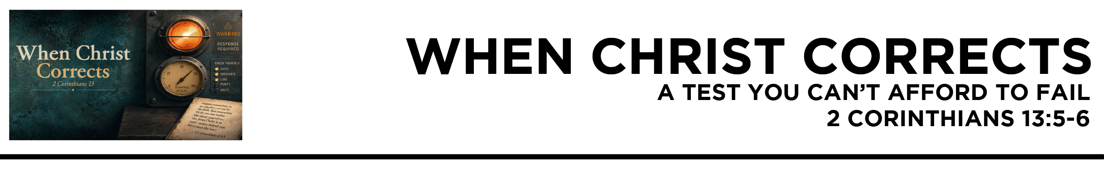

Ask Yourself…
2 Cor. 13:5 Examine yourselves, to see whether you are in the faith. Test yourselves. Or do you not realize this about yourselves, that Jesus Christ is in you?—unless indeed you fail to meet the test! 6 I hope you will find out that we have not failed the test. (ESV)
Dr. Mike Fabarez • Compass Bible Church • August 22 & 23, 2026 • 2 Corinthians, week 57 • Msg. 26-29

- Do ____________________________________ (v.5a)

Ask Yourself…
- Do __________________________________________ (v.5b)

Ask Yourself…
- Does ____________________________________ (vv.5c-6)

Application Questions
These questions are provided for your further study and application of today’s sermon. Thoughtfully writing out the answers to these questions will help to drive home the point of today’s study. It is also helpful when you are able to discuss your answers with others. For more information about small groups at Compass Bible Church that utilize these questions as the basis for their weekly discussion, please call the church office at (949) 540-0699 or email us at SmallGroups@CompassChurch.org.

1. Read Matthew 7:21-23. What gave these people such confidence that they belonged to Christ, and why was that confidence misplaced? What should we learn from their tragic mistake?

2. Read 2 Corinthians 11:4. What distorted versions of Jesus are especially attractive in our culture today? Why are people often more willing to embrace those versions than the Christ presented in Scripture?

3. Read James 2:17-19. Why is merely agreeing that Christian doctrines are true insufficient evidence of saving faith? What should genuine faith produce that mere intellectual agreement does not?

4. Read Acts 26:18-20. Looking back on your conversion, what changes began to appear in your life that were “in keeping with” genuine repentance?

5. Read Lamentations 3:40. What distractions, fears, or rationalizations keep us from seriously examining our ways? When and where could you regularly create enough quiet and honesty before God to do this well?

Streaming of both the audio and video of today’s sermon is available on the Compass website (CompassChurch.org). The following related sermons are also available for downloading or streaming on the Focal Point Website and App (FPR.org).
Msg. 12-27 – Responding to the King of Kings
Msg. 06-14 – A Crash Course in Repentance & Faith
Msg. 24-02 – The Gift of Repentance
Msg. 08-32 – Making Sure You’re Repentant
Msg. 12-18 – Guilt & Forgiveness
Msg. 13-02 – Why “As You Are” Can’t Stay that Way
Msg. 06-52 – Avoiding the Biggest Misunderstanding
Here are some books that may assist you in a deeper study of the truths presented in today’s sermon. While Pastor Mike cannot endorse every concept presented in each book, he does believe these resources will be helpful in profitably thinking through today’s topic.
Chantry, Walter J. Today’s Gospel: Authentic or Synthetic? Banner of Truth, 1970.
Geisler, Norman L., and Ron Rhodes. Correcting the Cults. Baker Books, 2005.
Grudem, Wayne. “Free Grace” Theology: Five Ways It Diminishes the Gospel. Crossway, 2016.
MacArthur, John. The Gospel According to Jesus: What Is Authentic Faith? Zondervan, 2008.
McDowell, Josh, and Don Stewart. Handbook of Today’s Religions. Thomas Nelson, 1996.
Metzger, Will. Tell the Truth: The Whole Gospel to the Whole Person by Whole People. IVP, 1981.
Rhodes, Ron. Handbook on Cults & New Religions: What Do They Believe? Harvest House Publishers, 2005.
Roberts, Richard Owen. Repentance: The First Word of the Gospel. Crossway Books, 2002.
Sire, James W. Scripture Twisting: Twenty Ways the Cults Misread the Bible. InterVarsity Press, 1980.
Sproul, R. C. Faith Alone: The Evangelical Doctrine of Justification. Baker Books, 1995.
Venning, Ralph. The Sinfulness of Sin. Banner of Truth, 1997.
Watson, Thomas. The Doctrine of Repentance. Banner of Truth, 1987.
Whitney, Donald S. How Can I Be Sure I’m a Christian? What the Bible Says About Assurance. NavPress, 1994.
Daily Bible Reading Schedule
Aug. 23rd Ps.119:105-176 & 1Cor.5
Aug. 24th Ps.120-123 & 1Cor.6
Aug. 25th Ps.124-127 & 1Cor.7:1-24
Aug. 26th Ps.128-131 &1Cor.7:25-40
Aug. 27th Ps.132-135 & 1Cor.8
Aug. 28th Ps.136-138 & 1Cor.9
Aug. 29th Ps.139-141 & 1Cor.10:1-13
Aug. 30th Ps.142-144 & 1Cor.10:14-33

