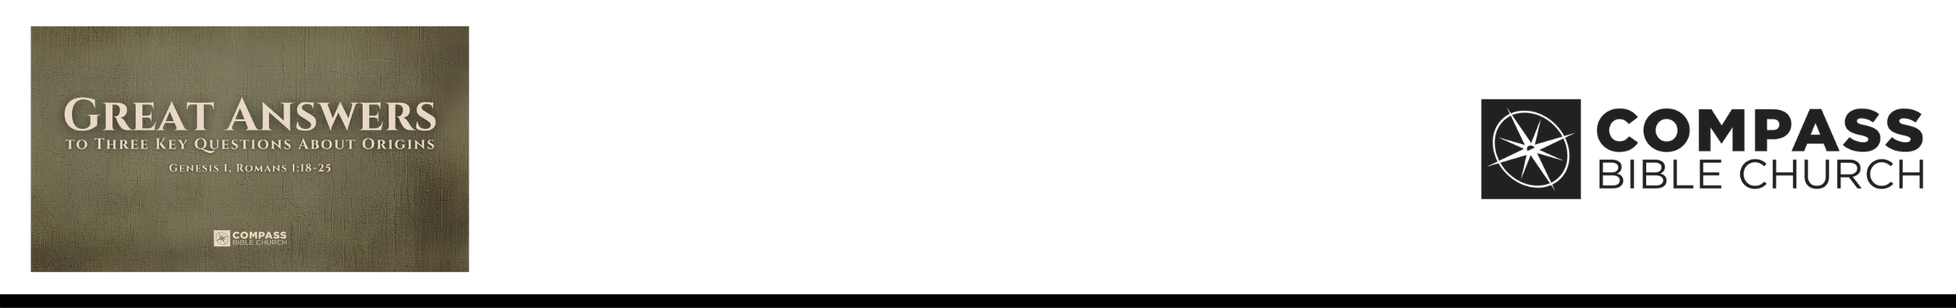

Dr. Randy Guliuzza • Compass Bible Church • August 29 & 30, 2026 • Msg. G26-07

- Are __________________________________________________
(Rom. 1:20; Eph. 2:10)

- Is ____________________________________________________
(Gen. 3:1-9; Rom. 5:12, 11:32; Gal. 3:22, 1 Cor. 15:22, 45)

- How __________________________________________________
(Acts 17:11; Deut. 30:11-14; John 14:16-17, 15:26, 16:13-14; 1 Jn. 2:19-21, 27)

Application Questions
These questions are provided for your further study and application of today’s sermon. Thoughtfully writing out the answers to these questions will help to drive home the point of today’s study. It is also helpful when you are able to discuss your answers with others. For more information about small groups at Compass Bible Church that utilize these questions as the basis for their weekly discussion, please call the church office at (949) 540-0699 or email us at SmallGroups@CompassChurch.org.

1. Read Psalm 119:18. What are some of the biblical truths that impressed you in this weekend’s sermon?

2. Read 2 Timothy 4:1-4. What aspects of this weekend’s message do you think will be rejected by those who hold a low view of Scripture?

3. Read Psalm 19:7-11. What in this biblical sermon will provide some of the effects in your life that are listed in this passage?

4. Read Matthew 7:24-27. What are some of the applicational steps you will take as a follow up from the sermon you heard this weekend?

5. Read Romans 15:14-15. What part of this sermon will be helpful as you seek to minister to others?

This Week’s
Bible Reading Schedule
August 30th
Ps.142-144 & 1Cor.10:14-33
August 31st
Ps.145-147 & 1Cor.11:1-15
September 1st
Ps.148-150 & 1Cor.11:16-34
September 2nd
Prov.1-2 & 1Cor.12
September 3rd
Prov.3-4 & 1Cor.13
September 4th
Prov.5-6 & 1Cor.14:1-20
September 5th
Prov.7-8 & 1Cor.14:21-40
September 6th
Prov.9-10 & 1Cor.15:1-32

Here are some helpful and informative books authored by today’s guest preacher on a variety of timely topics.
Guliuzza, Randy. Aware & Prepared. Institute for Creation Research, 2024.
________. Clearly Seen: Constructing Solid Arguments for Design. Institute for Creation Research, 2012.
________. Five Minutes with a Darwinist: Exposing the FLUFF of Evolution. Institute for Creation Research, 2008.
________. Made in His Image: Examining the Complexities of the Human Body. Institute for Creation Research, 2009.
________. Twenty Evolutionary Blunders. Institute for Creation Research, 2017.
Guliuzza, Randy J., contributor. Animals: How Creature Features Defy Evolution. Institute for Creation Research, 2024.
________. Creation Basics & Beyond. 2nd ed. Institute for Creation Research, 2020.
________. Guide to Creation Basics. Institute for Creation Research, 2013.
________. Guide to the Human Body. Institute for Creation Research, 2015.
________. Sea Creatures: Discovering God’s Underwater Wonders. Institute for Creation Research, 2024.

