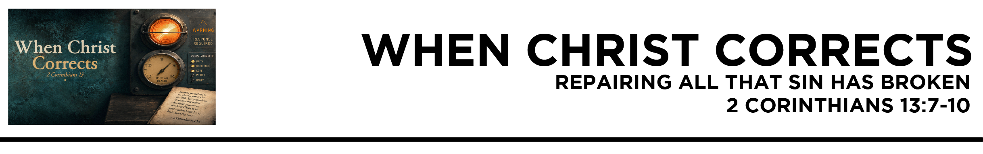

2 Cor. 13:7 But we pray to God that you may not do wrong—not that we may appear to have met the test, but that you may do what is right, though we may seem to have failed. 8 For we cannot do anything against the truth, but only for the truth.
9 For we are glad when we are weak and you are strong. Your restoration is what we pray for.
10 For this reason I write these things while I am away from you, that when
I come I may not have to be severe in my use of the authority that the
Lord has given me for building up and not for tearing down. (ESV)
Dr. Mike Fabarez • Compass Bible Church • September 5 & 6, 2026 • 2 Corinthians, week 58 • Msg. 26-30

- Turn __________________________________ (vv.7-8)

- Repair ______________________________________ (v.9)

- Fix _________________________________________ (v.10)

Application Questions
These questions are provided for your further study and application of today’s sermon. Thoughtfully writing out the answers to these questions will help to drive home the point of today’s study. It is also helpful when you are able to discuss your answers with others. For more information about small groups at Compass Bible Church that utilize these questions as the basis for their weekly discussion, please call the church office at (949) 540-0699 or email us at SmallGroups@CompassChurch.org.

1. Read Titus 3:5-8. Why is Paul able to “insist” that believers devote themselves to good works (v.8) without contradicting his teaching that salvation is entirely by God’s mercy rather than our works (vv.5-7)?

2. Read 1 Peter 3:10-13. What would you say to a new Christian who agrees that sin is wrong but does not yet sense much urgency about turning from it and pursuing what is good?

3. Read Luke 19:5-10. Why should a genuine work of salvation produce not only sorrow over sin, but concrete efforts to repair the damage it has caused?

4. Read Matthew 5:23-24. Why is it sometimes easier to confess sin to God than to face the person your sin has affected and seek reconciliation?

5. Read Revelation 2:5. How does this passage confront the casual attitude that says, “I know I need to deal with this, but I’ll get to it later”?

Streaming of both the audio and video of today’s sermon is available on the Compass website (CompassChurch.org). The following related sermons are also available for downloading or streaming on the Focal Point Website and App (FPR.org).
Msg. 26-27 – Taking Every Warning Seriously
Msg. 24-06 – The Path of Sanctification
Msg. 25-39 – Inspecting Our Repentance
Msg. 24-06 – The Path of Sanctification
Msg. 13-03 – Being Sure to Move from Creeds to Deeds
Msg. 21-34 – The Life-Changing Message
Msg. 09-32 – 09-36 – Set Free to Live Right (a 5-part series)
Here are some books that may assist you in a deeper study of the truths presented in today’s sermon. While Pastor Mike cannot endorse every concept presented in each book, he does believe these resources will be helpful in profitably thinking through today’s topic.
Adams, Jay. From Forgiven to Forgiving. Calvary Press, 1997.
Brauns, Chris. Unpacking Forgiveness: Biblical Answers for Complex Questions. Crossway, 2008.
Carson, D. A. Love in Hard Places. Crossway Books, 2002.
DeYoung, Kevin. The Hole in Our Holiness. Crossway, 2012.
Hendricks, Howard G., and William D. Hendricks. Living by the Book. Moody Press, 1991.
Packer, J. I. Rediscovering Holiness. Servant Publications, 1999.
Pink, A. W. Repentance. Triangle Press, 1996.
Ralevic, Simo. The Tongue: Our Measure. Banner of Truth, 1996.
Ryle, J. C. Holiness: Its Nature, Hindrances, Difficulties and Roots. Charles Nolan Publishers, 2001.
Sande, Ken. The Peacemaker: A Biblical Guide to Resolving Personal Conflicts. Baker Books, 1997.
Saucy, Robert L. Scripture: Its Power, Authority, and Relevance. Word Publishing, 2001.
Smith, William P. How to Love Difficult People: Receiving and Sharing God’s Mercy. New Growth Press, 2008.
Ward, Timothy. Words of Life: Scripture as the Living and Active Word of God. InterVarsity Press, 2009.
Daily Bible Reading Schedule
Sept. 6th Prov.9-10 & 1Cor.15:1-32
Sept. 7th Prov.11-12 & 1Cor.15:33-58
Sept. 8th Prov.13-14 & 1Cor.16
Sept. 9th Prov.15-16 & 2Cor.1
Sept. 10th Prov.17-18 & 2Cor.2
Sept. 11th Prov.19-20 & 2Cor.3
Sept. 12th Prov.21-22 & 2Cor.4
Sept. 13th Prov.23-24 & 2Cor.5

