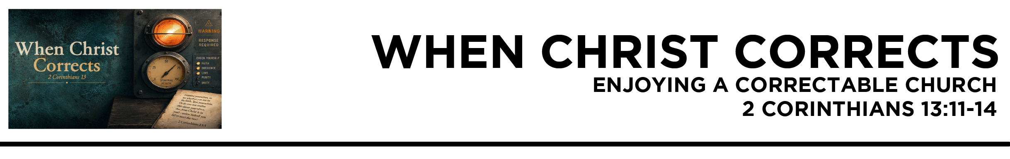

2 Cor. 13:11 Finally, brothers, rejoice. Aim for restoration, comfort one another, agree with one another, live in peace; and the God of love and peace will be with you. 12 Greet one another with a holy kiss. 13 All the saints greet you. 14 The grace of the Lord Jesus Christ and the love of God and the fellowship of the Holy Spirit be with you all. (ESV)
Dr. Mike Fabarez • Compass Bible Church • September 12 & 13, 2026 • 2 Corinthians, week 59 • Msg. 26-31

- Do _____________________________________ (v.11)

- Show _________________________________ (vv.12-13)

- Pray __________________________________________ (v.14)

Application Questions
These questions are provided for your further study and application of today’s sermon. Thoughtfully writing out the answers to these questions will help to drive home the point of today’s study. It is also helpful when you are able to discuss your answers with others. For more information about small groups at Compass Bible Church that utilize these questions as the basis for their weekly discussion, please call the church office at (949) 540-0699 or email us at SmallGroups@CompassChurch.org.

1. Read Hebrews 10:24-25. What does this passage say should be happening among Christians that can’t be done by slipping in the back row on the weekend? What is lost when a Christian attends but never connects?

2. Read Ephesians 4:1-3. Obviously, effort is involved in maintaining our unity as we saw in 2 Corinthians 13. Which of these qualities in Ephesians 4:1-3 would cost you the most to practice this week?

3. Read Philippians 4:4. If you realized on the way to church that you were negative, distracted, or discouraged, what could you pray about and think about in order to obey the command to rejoice?

4. Read 1 Thessalonians 5:11. Most Christians intend to encourage others far more than they actually do. What stops you? Is it not knowing what to say, fear, or simply not seeing the need? What would change that this week?

5. Read 1 John 3:18. Who in your church could benefit from a concrete expression of your love and care this week, and what could you do?

Streaming of both the audio and video of today’s sermon is available on the Compass website (CompassChurch.org). The following related sermons are also available for downloading or streaming on the Focal Point Website and App (FPR.org).
Msg. 12-04 – Learning to Encourage One Another
Msg. 17-09 – Providing Godly Encouragement to Your Friends
Msg. 14-24 – Your Fraternity of Hearers
Msg. 20-40 – Enjoying God’s Growing Family
Msg. 19-36 – The Unrivaled Fellowship of His Church
Msg. 13-57 – Regeneration & The Baptism of the Holy Spirit
Msg. 13-58 – The Indwelling & Sealing of the Holy Spirit
Here are some books that may assist you in a deeper study of the truths presented in today’s sermon. While Pastor Mike cannot endorse every concept presented in each book, he does believe these resources will be helpful in profitably thinking through today’s topic.
Alcorn, Randy. Happiness. Tyndale House Publishers, 2015.
Bowman, Robert M., Jr. Why You Should Believe in the Trinity. Baker Books, 1989.
Edwards, Jonathan. Charity and Its Fruits. Banner of Truth, 1969.
Erickson, Millard J. Making Sense of the Trinity. Baker Books, 2000.
Holmes, Jonathan. The Company We Keep: In Search of Biblical Friendship. Cruciform Press, 2014.
Pettegrew, Larry D. The New Covenant Ministry of the Holy Spirit. Kregel Publications, 2001.
Ryken, Philip Graham, ed. The Communion of the Saints. P&R Publishing, 2001.
Strauch, Alexander. The Hospitality Commands: Building Loving Christian Community. Lewis & Roth Publishers, 2016.
Swindoll, Charles R. Improving Your Serve: The Art of Unselfish Living. W Publishing Group, 2002.
Welch, Edward T. Side by Side: Walking with Others in Wisdom and Love. Crossway, 2015.
White, James R. The Forgotten Trinity: Recovering the Heart of Christian Belief. Bethany House Publishers, 1998.
Whitney, Donald S. Spiritual Disciplines Within the Church. Moody Press, 1996.
Wilkins, Steve. Face to Face: Meditations on Friendship and Hospitality. Canon Press, 2002.

Daily Bible Reading Schedule
Sept. 13th Prov.23-24 & 2Cor.5
Sept. 14th Prov.25-27 & 2Cor.6
Sept. 15th Prov.28-29 & 2Cor.7
Sept. 16th Prov.30-31 & 2Cor.8
Sept. 17th Ecc.1-3 & 2Cor.9
Sept. 18th Ecc.4-6 & 2Cor.10
Sept. 19th Ecc.7-9 & 2Cor.11:1-15
Sept. 20th Ecc.10-12 & 2Cor.11:16-33

