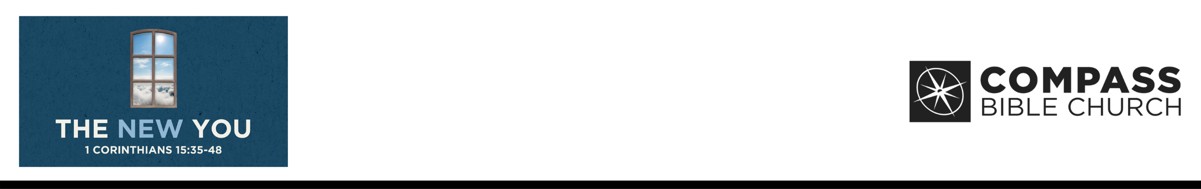

1 Corinthians 15:35
But someone will ask, “How are the dead raised? With what kind
of body do they come?”
36 You foolish person! What you sow does not come to life unless it dies. 37 And what you sow is not the body that is to be, but a bare kernel, perhaps of wheat or of some other grain. 38 But God gives it a body as he has chosen, and to each kind of seed its own body. 39 For not all flesh is the same, but there is one kind for humans, another for animals, another for birds, and another for fish. 40 There are heavenly bodies and earthly bodies, but the glory of the heavenly is of one kind, and the glory of the earthly is of another.
41 There is one glory of the sun, and another glory of the moon, and another glory of the stars; for star differs from star
in glory. 42 So is it with the resurrection of the dead. What is sown is perishable; what is raised is imperishable. 43 It is sown in dishonor; it is raised in glory. It is sown in weakness; it is raised in power. 44 It is sown a natural body; it is raised
a spiritual body. If there
is a natural body, there
is also a spiritual body.
45 Thus it is written, “The first man Adam became
a living being”; the last Adam became a life-giving spirit. 46 But it is not the spiritual that is first but the natural, and then the spiritual. 47 The first man was from the earth, a man of dust; the second man is from heaven. 48 As was the man of dust, so also are those who are of the dust, and as is the man of heaven, so also are those who are of heaven. (ESV)

Philip De Courcy • Compass Bible Church • September 19 & 20, 2026 • Msg. G26-08

- The New Body ______________________________

- The New Body ______________________________

- The New Body _______________________________

- The New Body ____________________________

- The New Body _____________________________

- The New Body ________________________

Application Questions
These questions are provided for your further study and application of today’s sermon. Thoughtfully writing out the answers to these questions will help to drive home the point of today’s study. It is also helpful when you are able to discuss your answers with others. For more information about small groups at Compass Bible Church that utilize these questions as the basis for their weekly discussion, please call the church office at (949) 540-0699 or email us at SmallGroups@CompassChurch.org.

1. Discuss the importance of Christ's resurrection to Christianity and the Christian.

2. How does the new and better you in the future help you better live today?

3. Taking the image of the seed, discuss the continuity between your old body and your new body and the fact that just like a seed you will come forth in a more glorious form.

4. Ponder the statement of C.S. Lewis who said that "Christianity is the most materialistic of all the world religions." Do you fully realize that our future is physical and material, a new body in a new world?

5. Reflect on the three stages of salvation, justification, sanctification and glorification. Discuss the wonderful truth that we will be saved to sin no more and will have a pure body.

6. Do you realize that you are but a shadow of your future self? Discuss.
This Week’s
Bible Reading Schedule
September 20th
Ecc.10-12 & 2Cor.11:16-33
September 21st
Song 1-3 & 2Cor.12
September 22nd
Song 4-5 & 2Cor.13
September 23rd
Song 6-8 & Gal.1
September 24th
Is.1-3 & Gal.2
September 25th
Is.4-6 & Gal.3
September 26th
Is.7-9 & Gal.4
September 27th
Is.10-12 & Gal.5

Here are some helpful and informative books authored by today’s guest preacher on a variety of timely topics.
De Courcy, Philip. Contentment: Spelled Out. Know the Truth, 2022.
________. Emergency Rations: Surviving the Struggles of Life. Christian Focus Publications, 2019.
________. Everyday Faith: A Study in the Book of Ruth. Three Sixteen Publishing, 2026.
________. Handling the Pressure. Know the Truth, 2019.
________. Help! I’m Anxious. Shepherd Press, 2018.
________. Life After Life: Exploring the Bible’s Wonderful Promises About Heaven and Eternity. Harvest House, 2026.
________. Standing Room Only. Emerald House Group, 1997.
________. Take Cover: Finding Peace in God’s Protection. Regnery Publishing, 2018.
________. You Go, Girl: How Women Build Up the Church. Know the Truth, 2021.

