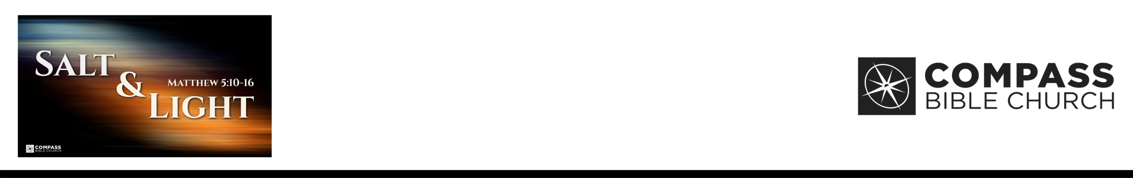

Matthew 5:10 “Blessed are those who are persecuted for righteousness' sake, for theirs is the kingdom of heaven. 11 “Blessed are you when others revile you and persecute you and utter all kinds of evil against you falsely on my account. 12 Rejoice and be glad, for your reward is great in heaven, for so they persecuted the prophets who
were before you. 13 “You are the salt of the earth, but if salt has lost its taste, how shall its saltiness be restored? It
is no longer good for anything except
to be thrown out and trampled under people's feet. 14 “You are the light of the world. A city set on a hill cannot be hidden. 15 Nor do people light a lamp and put it under a basket, but on a stand, and it gives light to all in the house. 16 In the same way, let your light shine before others, so that they may see your good works and give glory to your Father who is in heaven.
(ESV)

Dr. Shannon Hurley • Compass Bible Church • September 26 & 27, 2026 • Msg. G26-09

FIVE KEY WORDS…

- ____________________________ (v.10)

- _______________________ (vv.10-12)

- ____________________ (vv.13-15)

- _______________ (vv.13-15)

- ___________________ (vv.13-15)

Application Questions
These questions are provided for your further study and application of today’s sermon. Thoughtfully writing out the answers to these questions will help to drive home the point of today’s study. It is also helpful when you are able to discuss your answers with others. For more information about small groups at Compass Bible Church that utilize these questions as the basis for their weekly discussion, please call the church office at (949) 540-0699 or email us at SmallGroups@CompassChurch.org.

1. Read Matthew 5:1-9. Can you be characterized as someone who is poor in spirit, who mourns over your sin, is meek, hungering and thirsting for righteousness, is merciful, pure in heart, and a peacemaker?

2. Do you typically experience persecution for your faith? Explain why or why not.

3. Do you tend to be tempted to run from being salt and light due to fear of persecution? Is there an instance where you lacked boldness that you need to confess?

4. How is your community tangibly different because of your presence?

5. What can you do practically to let your light shine this week?

This Week’s
Bible Reading Schedule
September 27th
Is.10-12 & Gal.5
September 28th
Is.13-15 & Gal.6
September 29th
Is.16-18 & Eph.1
September 30th
Is.19-21 & Eph.2
October 1st
Is.22-23 & Eph.3
October 2nd
Is.24-26 & Eph.4
October 3rd
Is.27-28 & Eph.5
October 4th
Is.29-30 & Eph.6

