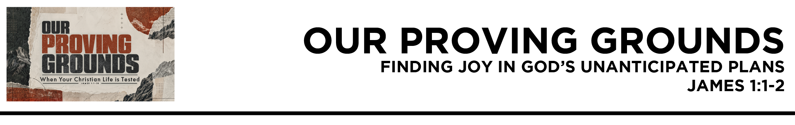

James 1:1 James, a servant of God and of the Lord Jesus Christ, To the twelve tribes
in the Dispersion: Greetings.
2 Count it all joy,
my brothers, when
you meet trials of various kinds, (ESV)
Dr. Mike Fabarez • Compass Bible Church • October 3 & 4, 2026 • James, week 1 • Msg. 26-32

- Find _______________________________ (v.1a)

- Choose ________________________________ (vv.1b-2)

Application Questions
These questions are provided for your further study and application of today’s sermon. Thoughtfully writing out the answers to these questions will help to drive home the point of today’s study. It is also helpful when you are able to discuss your answers with others. For more information about small groups at Compass Bible Church that utilize these questions as the basis for their weekly discussion, please call the church office at (949) 540-0699 or email us at SmallGroups@CompassChurch.org.

1. Read Galatians 1:13-16. If someone asked you tonight, "How did you become a Christian?", how would you briefly describe your life before Christ and the inside-out change God's grace has produced in you?

2. Read Genesis 50:20. How can seeing God’s providence in the painful chapters of your past deepen your worship and motivate your service to Christ?

3. Read 1 Timothy 1:12-17. Why should our sinful pre-Christian testimony produce humility and gratitude rather than ongoing embarrassment that keeps us from serving God?

4. Read Philippians 4:4. Paul wrote these words from prison. Why does rejoicing in the Lord in difficult circumstances often require a deliberate choice? What does that choice look like in practice?

5. Read 1 Thessalonians 5:16-18. Why can thoughtful thanksgiving change the way we view difficult circumstances? What specifically can we thank God for when the situation itself is unpleasant?

Streaming of both the audio and video of today’s sermon is available on the Compass website (CompassChurch.org). The following related sermons are also available for downloading or streaming on the Focal Point Website and App (FPR.org).
Msg. 19-30 – Unfazed by Sovereign Challenges
Msg. 18-04 – Submitting to Christ’s Sovereign Authority
Msg. 18-19 – God’s Good Plans
Msg. 20-22 – The Fear of God and Our Suffering
Msg. 19-13 – Fearless
Msg. 13-03 – Being Sure to Move from Creeds to Deeds
Msg. 21-34 – The Life-Changing Message

Here are some books that may assist you in a deeper study of the truths presented in today’s sermon. While Pastor Mike cannot endorse every concept presented in each book, he does believe these resources will be helpful in profitably thinking through today’s topic.
Bavinck, Herman. Saved by Grace. Reformation Heritage Books, 2013.
Cosby, Brian H. Suffering and Sovereignty. Reformation Heritage Books, 2012.
Dillehay, Tilly. Seeing Green: Don’t Let Envy Color Your Joy. Harvest House Publishers, 2018.
Fabarez, Mike. Envy: A Big Problem You Didn’t Know You Had. Moody Publishers, 2023.
Lawrence, Michael. Conversion: How God Creates a People. Crossway, 2017.
Mohler, Mary. Growing in Gratitude. The Good Book Company, 2018.
Pink, A. W. The Sovereignty of God. Banner of Truth, 2009.
Piper, John. 21 Servants of Sovereign Joy: Faithful, Flawed, and Fruitful. Crossway, 2018.
Piper, John, and Justin Taylor, eds. Suffering and the Sovereignty of God. Crossway, 2006.
Ryle, J. C. Regeneration: What It Means and Why It’s Necessary. Christian Focus Publications, 2003.
Schreiner, Thomas R., and Bruce A. Ware, eds. Still Sovereign. Baker Books, 2000.
Swindoll, Charles R. Joseph: A Man of Integrity and Forgiveness. Thomas Nelson, 1998.
Wiersbe, Warren W., ed. Classic Sermons on Suffering. Kregel Publications, 1984.

Daily Bible Reading Schedule
Oct. 4th Is.29-30 & Eph.6
Oct. 5th Is.31-33 & Phil.1
Oct. 6th Is.34-36 & Phil.2
Oct. 7th Is.37-38 & Phil.3
Oct. 8th Is.39-40 & Phil.4
Oct. 9th Is.41-42 & Col.1
Oct. 10th Is.43-44 & Col.2
Oct. 11th Is.45-47 & Col.3

