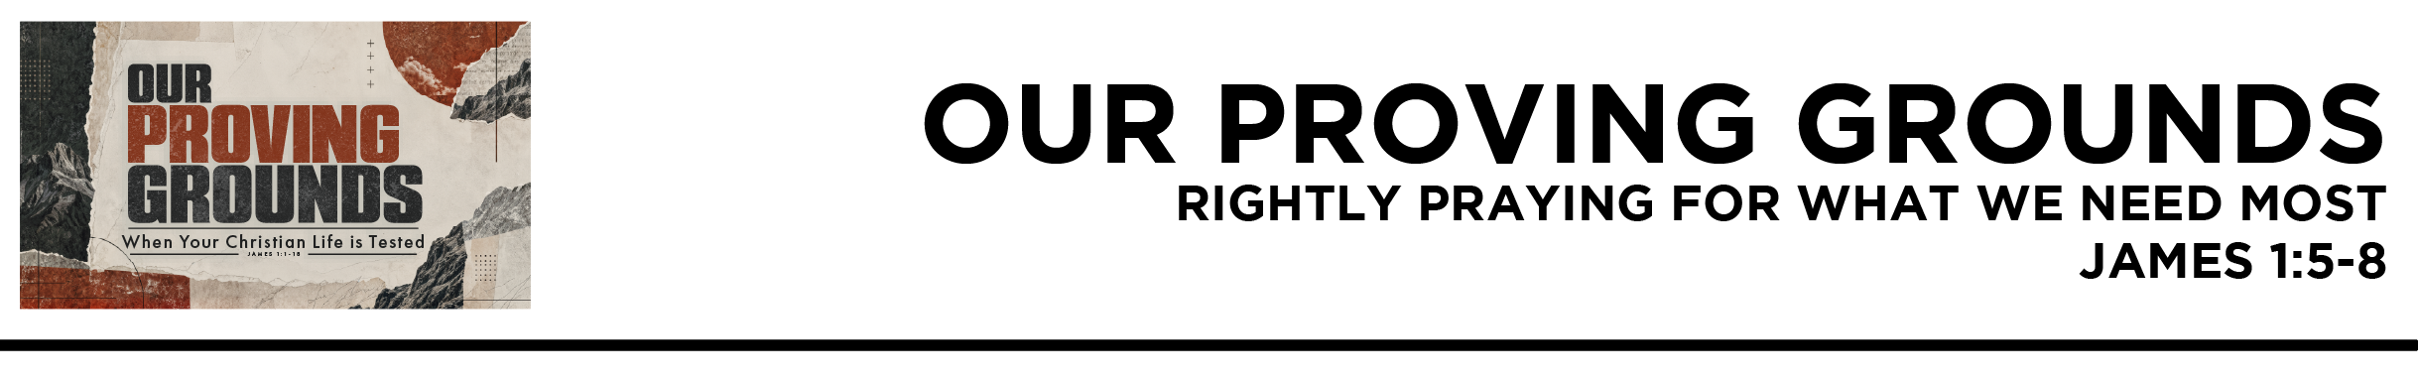
James 1:5 If any of you lacks wisdom, let him ask God, who gives generously to all without reproach, and it will be given him. 6 But let him ask in faith, with no doubting, for the one who doubts is like a wave of the sea that is driven and tossed by the wind. 7 For that person must not suppose that he will receive anything from the Lord; 8 he is a double-minded man, unstable in all his ways. (ESV)

Dr. Mike Fabarez • Compass Bible Church • October 24 & 25, 2026 • James, week 3 • Msg. 26-35

- Understand ________________________________ (v.5a)

- Trust _______________________________________ (v.5b)

- Ask _______________________________________________
(vv.6-8)

Application Questions
These questions are provided for your further study and application of today’s sermon. Thoughtfully writing out the answers to these questions will help to drive home the point of today’s study. It is also helpful when you are able to discuss your answers with others. For more information about small groups at Compass Bible Church that utilize these questions as the basis for their weekly discussion, please call the church office at (949) 540-0699 or email us at SmallGroups@CompassChurch.org.

1. Read Proverbs 3:5-6 and Psalm 119:7. Looking back, which hard times proved most spiritually productive in your life? What did they teach you that easier seasons never could?

2. Read Psalm 73:2-6, 16-17, 23-25. Why is it tempting to pull away from church when you’re hurting or confused? How has staying committed to corporate worship helped you see your circumstances from God’s perspective?

3. Read Hebrews 4:15-16. When you struggle, are you inclined to approach God confidently or hesitate because you feel inadequate? How should this passage shape the way you seek his help?

4. Read Psalm 62:8. The psalmist links trusting God with pouring out our hearts to him. Why do these two always rise or fall together? What can you do to strengthen both in your next trial?

5. Read Psalm 19:7-11. Which of the benefits of God’s Word listed here have you most needed during difficult seasons? How have hard times reshaped the way you read and study the Bible?

Streaming of both the audio and video of today’s sermon is available on the Compass website (CompassChurch.org). The following related sermons are also available for downloading or streaming on the Focal Point Website and App (FPR.org).
Msg. 10-18 – Praying Through the Pain
Msg. 15-21 – Asking with Confidence in a Good God
Msg. 20-21 – Real Wisdom
Msg. 19-11 – Faith-Filled Praying
Msg. 22-28 – Discerning God’s Will
Msg. 02-16 – How Grace Can Transform Your Ideas About God
Msg. 07-21 – Trusting God When Your Back’s Against the Wall

Here are some books that may assist you in a deeper study of the truths presented in today’s sermon. While Pastor Mike cannot endorse every concept presented in each book, he does believe these resources will be helpful in profitably thinking through today’s topic.
Alcorn, Randy. If God Is Good: Faith in the Midst of Suffering and Evil. Multnomah Books, 2009.
Barclay, William B. The Secret of Contentment. P&R Publishing, 2011.
Bonar, Horatius. Night of Weeping: When God’s Children Suffer. Christian Focus Publications, 1999.
Burroughs, Jeremiah. The Rare Jewel of Christian Contentment. Banner of Truth, 1981.
Carson, D. A. How Long, O Lord? Reflections on Suffering and Evil. Baker Books, 1990.
Elliott, Elisabeth. A Path Through Suffering. Servant Publications, 1990.
_________. The Liberty of Obedience. Servant Publications, 1987.
Flavel, John. Keeping the Heart. Christian Focus Publications, 2005.
Hegg, David. The Obedience Option: Because God Knows What’s Good for Us. Christian Focus Publications, 2010.
Hutchison, John C. Thinking Right When Things Go Wrong. Kregel Publications, 2005.
Piper, John. The Roots of Endurance. Crossway, 2002.
Schreiner, Thomas R., and Ardel B. Caneday. The Race Set Before Us. InterVarsity Press, 2001.
Watson, Thomas. The Art of Divine Contentment. Soli Deo Gloria Publications, 1995.

Daily Bible Reading Schedule
Oct. 25th Jer.14-16 & 1Tim.5
Oct. 26th Jer.17-19 & 1Tim.6
Oct. 27th Jer.20-22 & 2Tim.1
Oct. 28th Jer.23-24 & 2Tim.2
Oct. 29th Jer.25-26 & 2Tim.3
Oct. 30th Jer.27-28 & 2Tim.4
Oct. 31st Jer.29-30 & Titus 1
Nov. 1st Jer.31-32 & Titus 2

